The submitted manuscript should be presented in Word, letter size, double-spaced, in Times New Roman 12.
Margins should be 3 cm on each side and the page number should be placed in the upper right corner.

Title in English
Title in Spanish

ABSTRACT / RESUMEN
Summaries and abstracts must be presented in a structured way with the sections explicitly. This means that they must contain the following information:
- Introduction / objective (a brief description of the origin and objective of the study.
- Methodology (a detailed description of the participants, instruments and procedure)
- Results (a description of the main findings)
- Conclusions (a description of the implications of the study).
Maximum 250 words.
Introduction / objective: The dynamic and competitive environment requires companies to create value by means of innovation, therefore, the objective of the research was to explore whether the innovator’s skills of observation (IOS), questioning (IQS), experimentation (IES), networking (INS) affect marketing innovation (MI) through the innovator’s skill at connecting ideas (ISCI) in wooden furniture manufacturing companies in Puno-Peru.
Methodology: The study corresponds to the quantitative approach with explanatory scope and non-experimental-transectional design. The sample consisted of 73 owners or managers of furniture manufacturing companies in the Province of Puno-Peru, who were given a questionnaire with 34 items.
Results: The results of the structural model show that the variance of the ISCI is due to the positive effects of the IES and the INS. In addition, the model significantly explains the variance of MI.
Conclusions: The model explains and predicts the variance of both the ISCI and MI. On the other hand, the IES and the INS are the ones that directly and significantly affect the ISCI, and this in turn likewise affects the MI of the furniture manufacturing companies in the Province of Puno, Peru.

Keywords / Palabras Clave
6 – 12 English keywords related to the content of the article, separated by commas and in lower case, the location of the study is also a keyword.
6 -12 keywords in Spanish related to the content of the article, separated by commas and in lower case, the location of the study is also a keyword.

Keywords: Innovator competencies, innovation, marketing, structural equation model,
Companies, Provincia de Puno, Perú.
Palabras clave: competencias del innovador, innovación, marketing, modelo de ecuaciones estructurales, empresas, Provincia de Puno, Perú.

JEL
Add 4 JEL descriptors according to: https://www.aeaweb.org/econlit/jelCodes.php

JEL codes: C39, M31, O31, O39

1. Introduction
Text here …

-Format of textual citations:
Textual citations in Spanish with English marks (“ ”)

-In-text citations according to APA 7Ed (https://www.konradlorenz.edu.co/blog/norma-apa-septima-edicion/).

1.1. Subheadings
Text here …

2. Methodology
The methodology section should encompass various essential components to offer a thorough understanding of the study's approach and execution. Below are the key aspects that should be included:

* Data. This section provides a detailed description of the nature and quality of the data utilized in the study, including their sources, collection methods, timing of acquisition, and any other pertinent aspects. Additionally, it outlines the process of participant or unit selection, along with the criteria for inclusion and exclusion, while also evaluating the validity and reliability of the data collection instruments.

* Type, Scope, and Design. Here, the type of research (qualitative, quantitative, or mixed) is defined and justified, alongside its scope (exploratory, descriptive, correlational, explanatory, predictive, etc.). Based on these parameters, the specific study design is elaborated upon, whether it be experimental, non-experimental, grounded theory, or others.

* Procedure. This section entails a comprehensive account of the specific steps undertaken during the research, encompassing data collection, precise study protocols, and any experimental manipulations performed. It serves as a crucial aspect facilitating the reproducibility of the study by other researchers.

* Data Analysis. The techniques employed for statistical or qualitative analysis are elucidated and justified, along with the software utilized for data analysis.

* Ethical Considerations. Key ethical aspects of the study are addressed, including obtaining informed consent, ensuring data confidentiality, managing conflicts of interest, and safeguarding participants' privacy. Any ethical approvals obtained are disclosed, and measures taken to mitigate potential risks for participants are discussed. In cases involving secondary sources, explicit acknowledgment of their use is provided, along with access information to the repository where they can be accessed.

3. Results
Text here …

- Table format (Guidelines: APA 7).
All tables and figures must be presented in the original editable format (Word, Excel, among others), have a title in the text and include their respective sources.

Table 1. Table title short, clear and concise.
 | Category | Category | Category
Variable 1 | xxx* | xxx | xxx
Variable 2 | xxx | xxx | xxx
Variable 3 | xxx | xxx | xxx
Variable 4 | xxx | xxx | xxx
Note*: "notes" at the end of the table are supported in this format.
Source: (indicate whether it is the author's own elaboration or whether it has been taken from another text)

Table 1. Fornell-Larcker test of discriminant validity of constructs criterion.
Constructos | 1. CICR | 2. CIC | 3. CIE | 4. CICI | 5. IM | 6. CIO
1. CICR | 0.84
2. CIC | 0.71 | 0.71
3. CIE | 0.67 | 0.67 | 0.84
4. CICI | 0.69 | 0.66 | 0.69 | 0.73
5. IM | 0.55 | 0.53 | 0.58 | 0.67 | 0.74
6.CIO | 0.36 | 0.59 | 0.41 | 0.41 | 0.28 | 0.79
Source: own elaboration.
- Figure format (Guidelines APA 7):
Images should be inserted within the text and not occupy more than one page. The image must be submitted in color, high resolution PNG format in high resolution (300 ppi).
Figure 1. Title of the figure short, clear and concise.
Notes: (Explanatory note)
¹ Example…..
Source: (indicate whether it is the author's own elaboration or whether it has been taken from another text)

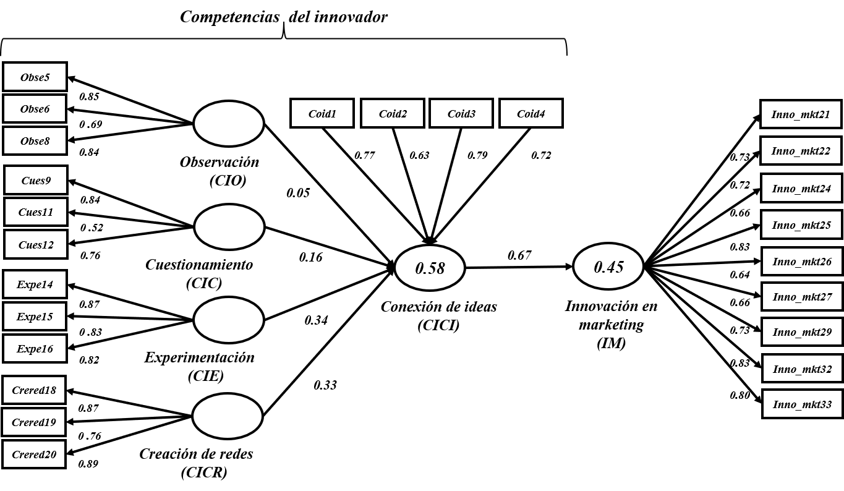
Figure 1. Structural model of innovator competencies and marketing innovation
Source: own elaboration.

-Equations:

In case of using equations, they must be numbered consecutively and between square brackets ([1], [2], [3]…). Mathematical symbols must be clear, legible and correspond to the equations.

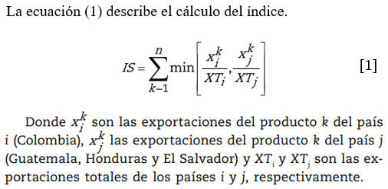

4. Discussion
Text here …

5. Conclusions
Text here …

6. Financing
Indicate institutional support from national and international competitive calls, or if it was financed only by authors.

7. Conflict of interest declaration
Indicate the circumstances that may unduly influence the professional judgment in relation to the primary interest (welfare and validity of the research) or for a secondary interest (financial gain, desire for notoriety, prestige, recognition and professional promotion).

8. References
- Enter list of references according to guidelines available in APA 7: https://www.konradlorenz.edu.co/blog/norma-apa-septima-edicion/
- The minimum number of references for research papers is 25 (30% from the last 2 years) and for review papers 50 references from the last 5 years (30% of which must correspond to the last 2 years).
- Check that the authors in the reference list correspond to those in the referenced text, and vice versa (check for cross-referencing)
- Check that all documents have a DOI. If this is not the case, enter the shortened links with https://bitly.com/
- Do not capitalize all words (especially in English) in titles. Only proper nouns and after periods and colons.

*Sections of the document marked in orange are technical comments. You must remove these texts from the final document before submitting it through the ScholarOne Manuscripts platform at the address https://mc04.manuscriptcentral.com/sumneg

The footnotes will be, exclusively, of an explanatory or clarifying nature, they must not include bibliographical references.

